San Francisco Enchantées 2019 Tournament

T-Shirt& Sweatshirt Pre-Order Form

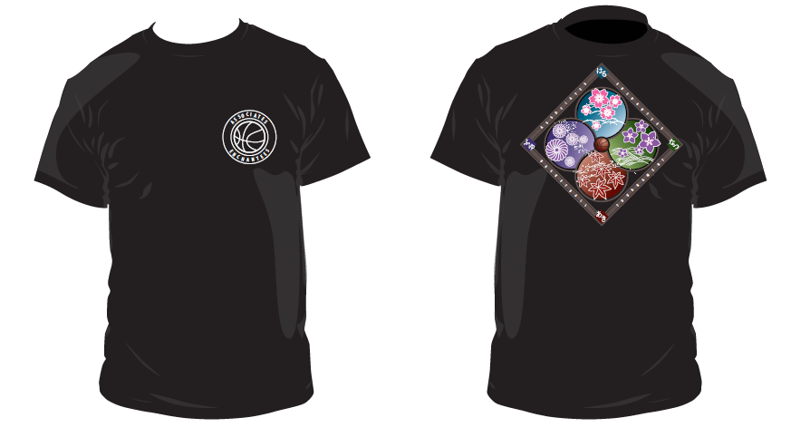

T-Shirt & Sweatshirts are BLACK

Pre-Order Only
ITEM DESCRIPTION  (ALL ADULT SIZES) | S | M | L | XL | QTY | XX-L | QTY | Price  S - XL | Price XX-L | TOTAL
T-Shirt Short sleeved |  |  |  |  |  |  |  | $18.00 | $21.00 | $
Pullover Hooded Sweatshirt |  |  |  |  |  |  |  | $30.00 | $33.00 | $
TOTAL |  |  |  |  |  |  |  |  |  | $

TEAM CONTACT INFO | All pre-orders will be available for pick-up at the division gym location.
Organization Name |  |  | Division/Grade Level
Team Contact |  |  | Contact Phone
Email Address
DUE DATE:  Please submit one form and one check by  SATURDAY, APRIL 6, 2019  Checks payable to  SAN FRANCISCO ENCHANTÉES |  | SEND TO:  San Francisco Enchantées  c/o BJ Baba  720 36th Ave.  San Francisco, CA 94121  (415) 412-2444 • enchanteesbears@yahoo.com

INTERNAL USE
Gym:
Date Received: | Check #: | $ | # of Units:

